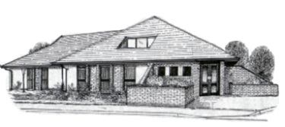

AUGUST 2021

The Vauxhall Times

We would like to begin by thanking the staff at The Vauxhall Surgery for their dedication keeping the practice open during such difficult times. We would also like to thank our patients for being so understanding and kind throughout the past year. The practice continued to provide an excellent standard of care, ensuing patients received their seasonal influenza vaccine as well as those vulnerable patients who received their COVID-19 vaccine more recently.

Changes to the surgery
We have been very lucky to make some changes to the practice recently. We have utilised the far corner of our reception area into brand new toilet facilities. This has enabled us to build another consulting room. We are also utilising our nurse’s room at the end of the corridor for possible covid-19 patients. This enables clinicians to examine patients with possible covid-19 symptoms without exposing the rest of the practice staff and patients to infection. This will remain for the foreseeable future.

econsult & my surgery app
Following the successful launch of eConsult in 2020 we have received positive feedback from patients. This online service has allowed us to provide patients with high standards of care throughout the numerous lockdowns and continuing pandemic, whilst working remotely and keeping our patients and staff safe.
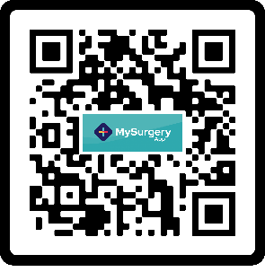
We are now looking forward to launching My Surgery App which allows patients to communicate with the surgery via modern technology. This will enable patients to complete forms, request medication, and check symptoms via the NHS Symptom Checker. To access My Surgery App scan the QR code below.

2021 flu campaign
At risk patients will shortly be receiving invitations to attend their seasonal influenza vaccination in September. It is important that you contact the surgery to book your appointment, either online or via the telephone. Please ensure you inform the practice if you wish to decline the vaccination this year.

Medical Students
We are now an approved training practice. This means we will have Trainee GPs (Registrars). The GP Registrars have at least three years of hospital experience as qualified doctors and are usually attached to the practice for 12 months. The surgery also provide experience for Cardiff University medical students who are navigating their way into the medical profession.

New Staff
We are delighted to welcome a new doctor to the team. Dr N Davis (f) will be joining the team towards the end of August as a fully qualified General Practitioner. We are also welcoming a new HCA to the team in September. Mrs R Absalom will be assisting Mrs T Mann with Phlebotomy and HCA tasks.
As part of our GP Registrar training we are also welcoming Dr S Hannoodee (f) (ST3) and Dr D Brzozowski (m) (ST2). They will be with us for the following 6-12 months.

Congratulations!
As a practice we are delighted to announce the news of two new arrivals. Dr S Lambert and Receptionist Sava have both given birth to baby boys. Both Mums and babies are healthy and doing well.

